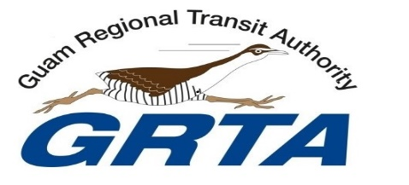 

**NOTICE TO THE PUBLIC**

**In observance of Memorial Day**

**GUAM REGIONAL TRANSIT AUTHORITY**will be closed

**NO BUS SERVICES**

**On Monday, May 30, 2022**

Fixed Route and Paratransit will resume regular bus operations on

May 31, 2022.

Please note that Paratransit Scheduling is available from 8 am-5 pm

For more information and accommodations, please call GRTA Transit Management Center at

647-7433 / 34 / 35.